Attitude: Nature, Components and Formation
Following are the salient features which contribute to the meaning of attitudes:
1. Attitudes refer to feelings and beliefs of individuals or groups of individuals. For example “He has a poor attitude”, “I like her attitude.”
2. The feelings and beliefs are directed towards other people, objects or ideas. When a person says, “I like my Job”. It shows that he has a positive attitude towards his job.
3. Attitudes often result in and affect the behaviour or action of the people. Attitudes can lead to intended behaviour if there are no external interventions.
4. Attitudes constitute a psychological phenomenon which cannot be directly observed. However, an attitude can be observed indirectly by observing its consequences. For example, if a person is very regular in his job, we may infer that he likes his job very much.
5. Attitudes are gradually acquired over a period of time. The process of learning attitude starts right from childhood and continues throughout the life of a person. In the beginning the family members may have a greater impact on the attitude of a child.
6. Attitudes are evaluative statements, either favourable or unfavourable. When a person says he likes or dislikes something or somebody, an attitude is being expressed.
7. All people, irrespective of their status and intelligence hold attitudes.
8. An attitude may be unconsciously held. Most of our attitudes may be about those which we are not clearly aware. Prejudice furnishes a good example.
Components of Attitudes:
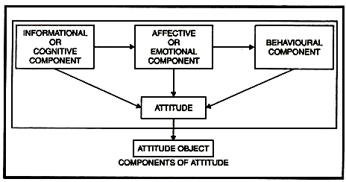
Attitudes comprise of three basic components: emotional, informational and behavioural.
These three components are described below:
1. Informational or Cognitive Component:
The informational component consists of beliefs, values, ideas and other information a person has about the object. It makes no difference whether or not this information is empirically correct or real. For example, a person seeking a job may learn from his own sources and other employees working in the company that in a particular company the promotion chances are very favourable. In reality, it may or may not be correct. Yet the information that person is using is the key to his attitude about that job and about that company.
2. Emotional or Affective Component:
The informational component sets the stage for the more critical part of an attitude, its affective component. The emotional components involve the person’s feeling or affect-positive, neutral or negative-about an object. This component can be explained by this statement.” I like this job because the future prospects in this company are very good”.
3. Behavioural Component:
The behavioural component consists of the tendency of a person to behave in a particular manner towards an object. For example, the concerned individual in the above case may decide to take up the job because of good future prospects. Out of the three components of attitudes, only the behavioural component can be directly observed. One cannot see another person’s beliefs (the informational component) and his feelings (the emotional component). These two components can only be inferred. But still understanding these two components is essential in the study of organisational behaviour or the behavioural component of attitudes.

ABC Model of Attitude:

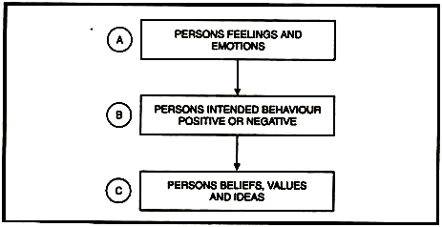
All the three components of attitude explained above constitute, what is OF called the ABC model. Here, in the ABC model, the alphabet A stands for Affective component, B for Behavioural and C for the cognitive component. The importance of this model is that to have a proper and thorough understanding of the concept of attitude, all the three components mentioned above must be properly assessed. It is only the behavioural component which can be directly observed, the other two components: affective and cognitive can however only be inferred.
Formation/Sources of Attitudes:
Attitudes refer to the feelings and beliefs of “individuals or groups of individuals. But the question is how these feelings and beliefs developed? The point which has been stressed by many people are that attitudes are acquired, but not inherited. A person acquires these attitudes from several sources.
The Attitudes are acquired but not important sources of acquiring attitudes are as discussed below:
1. Direct Personal Experience:
A person’s direct experience with the attitude object determines his attitude towards it. The personal experience of an individual, whether it is favourable or unfavourable, will affect his attitude deeply. These attitudes which are based on personal experience are difficult to change.
For example, an individual joins a new job, which is recommended to him by his friend. But when he joins the job, he find his work repetitive, supervisors too tough and co-workers not so co-operative, he would develop a negative attitude towards his job, because the quality of his direct experience with the job is negative.

2. Association:
Sometimes an individual comes across a new attitude object which may be associated with an old attitude object. In such a case, the attitude towards the old attitude object may be transferred towards the new attitude object. For example, if a new worker remains most of the time in the company of a worker, who is in the good books of the supervisor, and towards whom the supervisor has a positive attitude, the supervisor is likely to develop a favourable attitude towards the new worker also. Hence the positive attitude for the old worker has been transferred towards the new worker because of the association between the old and the new worker.
3. Family and Peer Groups:
Attitudes like values are acquired from parents, teachers and peer group members. In our early years, we begin modeling our attitudes after those we admire, respect or may be even fear. We observe the way our family and friends behave and we shape our attitudes and behaviour to align with theirs. We do so even without being told to do so and even without having direct experience. Similarly, attitudes are acquired from peer groups in colleges and organisations. For example, if the right thing is to visit “Hot Millions”, or the “Domino’s”, you are likely to hold that attitude. If your parents support one political party, without being told to do so, you automatically start favouring that party.
4. Neighbourhood:
The neighbourhood in which we live has certain cultural facilities, religious groupings and ethnic differences. Further, it has people, who are neighbours. These people may be Northerners, Southerners etc. The people belonging to different cultures have different attitudes and behaviours. Some of these we accept and some of these we deny and possibly rebel. The conformity or rebellion in some respects is the evidence of the attitudes we hold.

5. Economic Status and Occupations:
The economic status and occupational position of the individual also affect his attitude formation. Our socio-economic background influences our present and future attitudes. Research findings have shown that unemployment disturbs former religious and economic values. Children of professional class tend to be conservatives. Respect for the laws of the country is associated with increased years of higher education.
6. Mass Communications:
Attitudes are generally less stable as compared to values. Advertising messages for example, attempt to alter the attitude of the people toward a certain product or service. For example, if the people at Hyundai Santro can get you to hold a favourable feeling toward their cars, that attitude may lead to a desirable behaviour (for them)-your purchase of a Santro car.
All these sources can be illustrated with the help of the following figure:
